Name:-Chetana Ravindra More

Roll No:-77

Practical 1:

Set up a GitHub account and send an email message to friend telling to your friend about the account.

Create a GitHub account
If you don't already have a GitHub account, here's how to create one.
- Open https://github.com in a web browser, and then select Sign up.
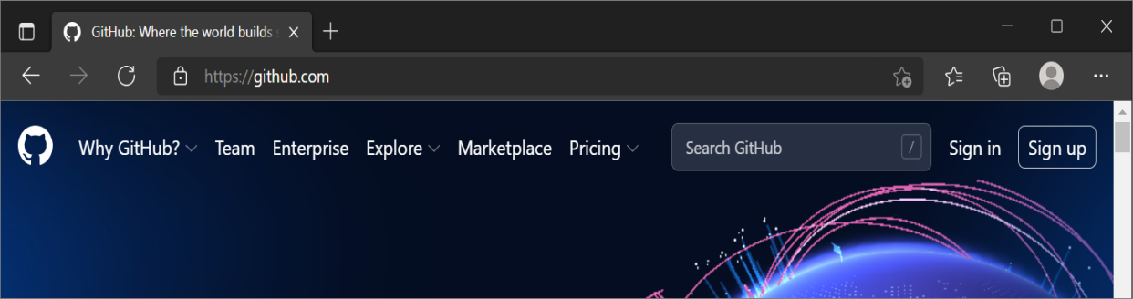
- Enter your email address.
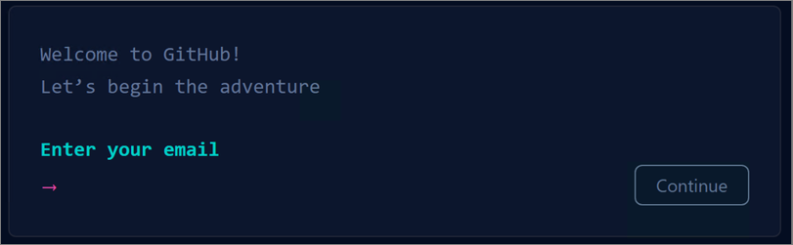
- Create a password for your new GitHub account, and Enter a username, too. Next, choose whether you want to receive updates and announcements via email, and then select Continue.
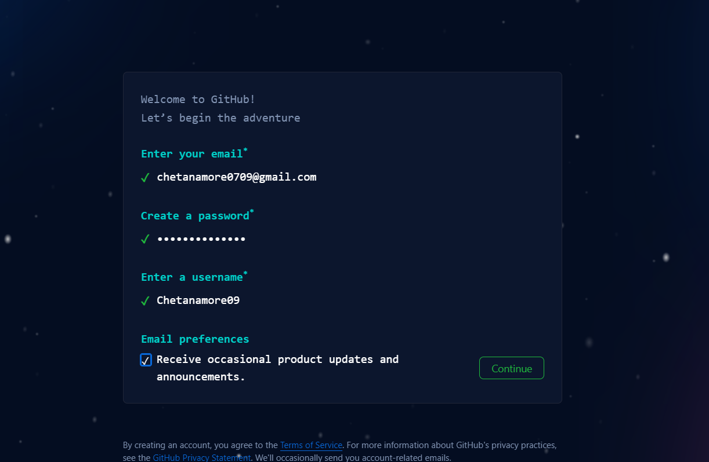
- Verify your account by solving a puzzle. Select the Start Puzzle button to do so, and then follow the prompts.
- After you verify your account, select the Create account button.
- Next, GitHub sends a launch code to your email address. Type that launch code in the Enter code dialog, and then press Enter.
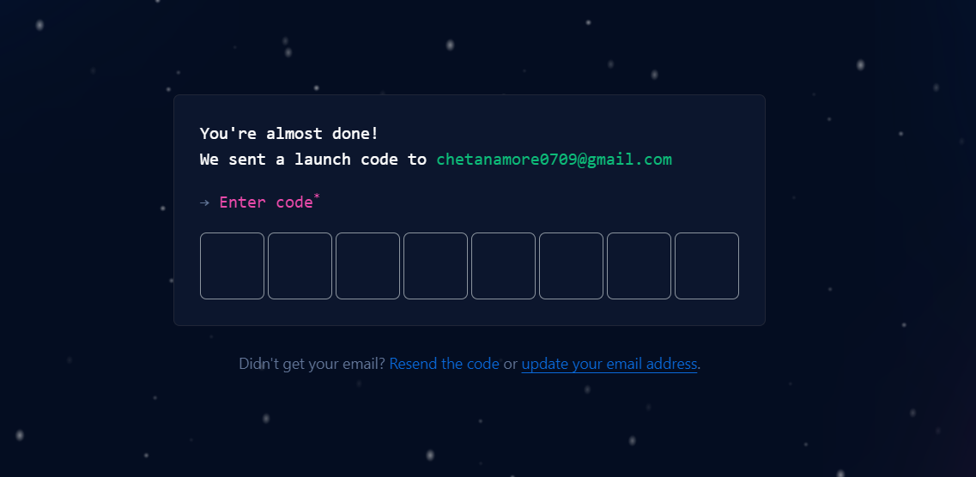
- GitHub asks you some questions to help tailor your experience. Choose the answers that apply to you in the following dialogs:
  - How many team members will be working with you?
  - What specific features are you interested in using?
- On the Where teams collaborate and ship screen, you can choose whether you want to use the Free account or the Team account. To choose the Free account, select the Skip personalization button.
GitHub opens a personalized page in your browser.
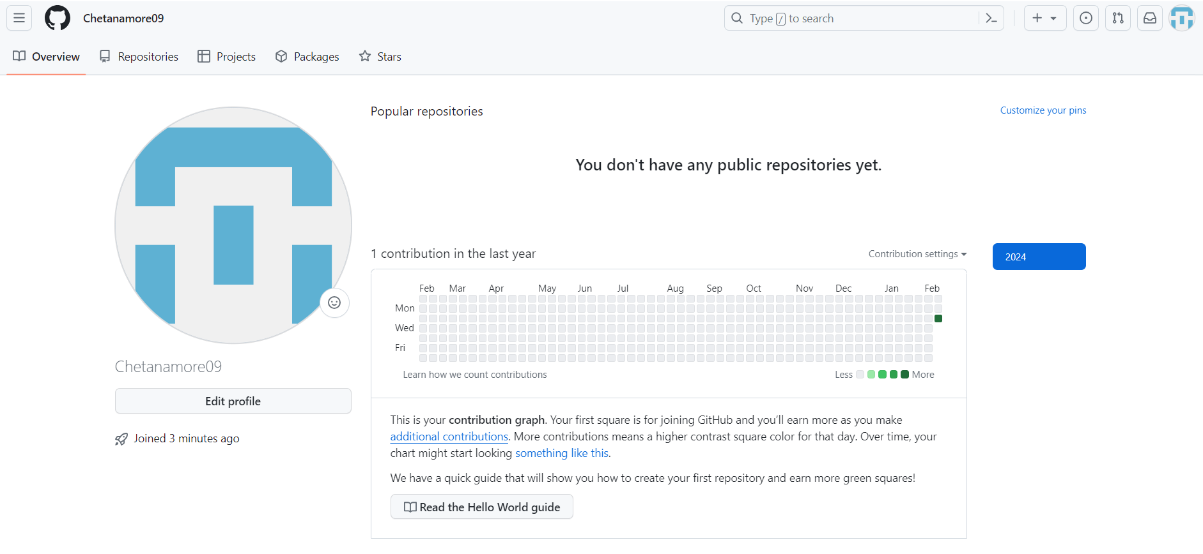
Congratulations! You've successfully created your GitHub account.
Paste the screen shots of email which you had sended to your friend through Github
Step1: Go to Github account and login.
Step2: After login, click on any created remote repository.
Step3: Go to settings of that particular remote repository and click on Email notifications and add the email id of your friend which you had to send the mail.
Step4: Make changes on your remote repository by editing any existing file or you can create any new file also.
Step5: Now, tell your friend to check his/her mail id by login.
